**Document Purpose:** To describe how to connect to the project forms published to Ona using ODK Collect. See ONA’s [documentation](https://help.ona.io/knowledge-base/guide-using-enketo-odk-collect/) on downloading ODK Collect for Android, as well as how to fill out and submit blank forms with or without live internet connection.

In ODK Collect, fist go to settings.

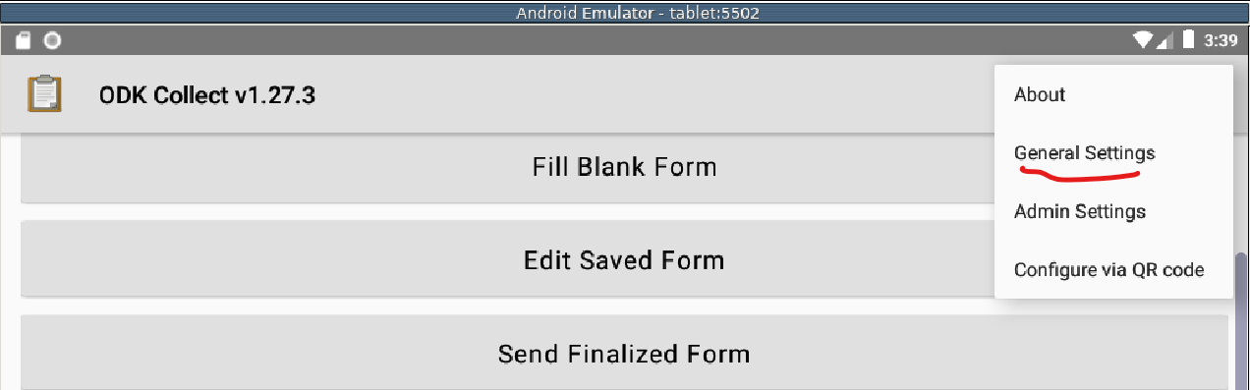

Then select Server.

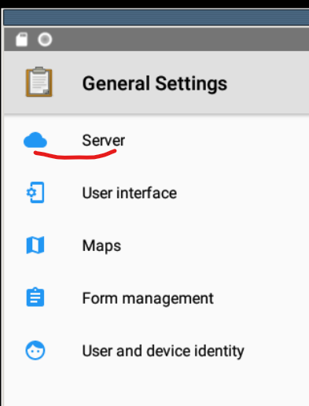

The *only* thing that needs to be changed on this screen is the url. Type in <https://odk.ona.io/pacafenet>. Use the back button to return to the main screen.

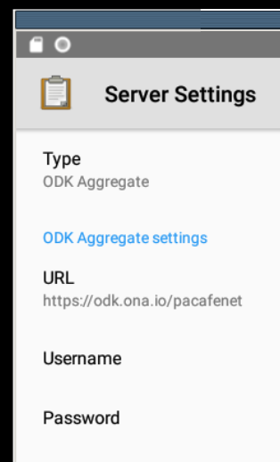

Select Get Blank Form.

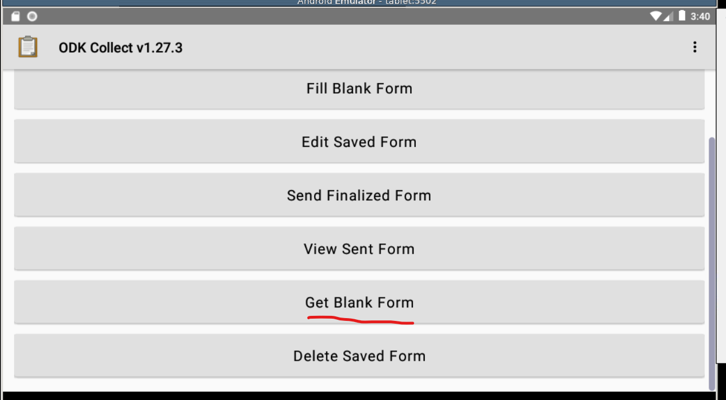

Now you will see the four forms published to Ona. The Equipment Information Form is for documenting newly added equipment or any changes to equipment info.

